
CASE STUDY ANALYSIS REPORT
MediSync AI
Intelligent Hospital Resource and Patient Flow Management System
Prepared by: Anushka Maniyam(192525411)
Course code:CSA1012

Table of Contents
Section | Page
1. Understanding the Problem Statement | 3
2. Key Stakeholders and Challenges | 4
3. Analysis of the Current Approach | 5
4. Proposed Software Solution | 6
5. Methodology / Framework Justification | 8
6. Expected Outcomes and Limitations | 10
7. Implementation Roadmap and Timeline | 11
8. Cost-Benefit Analysis | 13
9. Risk Management Plan | 15
Conclusion | 16

1. Understanding the Problem Statement
Problem
Hospitals today handle a large number of patients every day, but they often struggle to manage beds, staff, and equipment efficiently. Information about which beds are free, which doctors are available, and how many patients are expected is usually scattered across different departments and updated manually. This causes overcrowding, long waiting times, and delays in patient care. MediSync AI is proposed as an AI-powered platform that brings all this information together in real time, predicts future patient demand, and recommends the best way to allocate hospital resources.
Objectives of the Proposed System
- Real-time monitoring: Track bed, staff, and equipment availability across the hospital at all times.
- Predictive planning: Use machine learning to forecast patient admissions and discharges before they happen.
- Smart allocation: Automatically recommend the best use of beds, staff, and equipment.
- Faster patient flow: Reduce waiting times by coordinating movement between departments.
- Better decisions: Give hospital administrators live dashboards to support quick, informed decisions.

Scope of the Problem
This case study focuses on the design of a software platform for hospital resource and patient flow management. It covers data collection from hospital systems and IoT devices, prediction of patient demand, optimization of resource allocation, and a dashboard for hospital staff. It does not cover the manufacturing of medical hardware or clinical treatment decisions — those remain the responsibility of medical professionals. The scope is limited to helping hospitals plan and coordinate resources more effectively using software and AI.

2. Key Stakeholders and Challenges
A stakeholder is anyone who is affected by, or has an interest in, the system. The diagram and table below identify the main stakeholders of MediSync AI, along with their roles and the challenges they currently face.
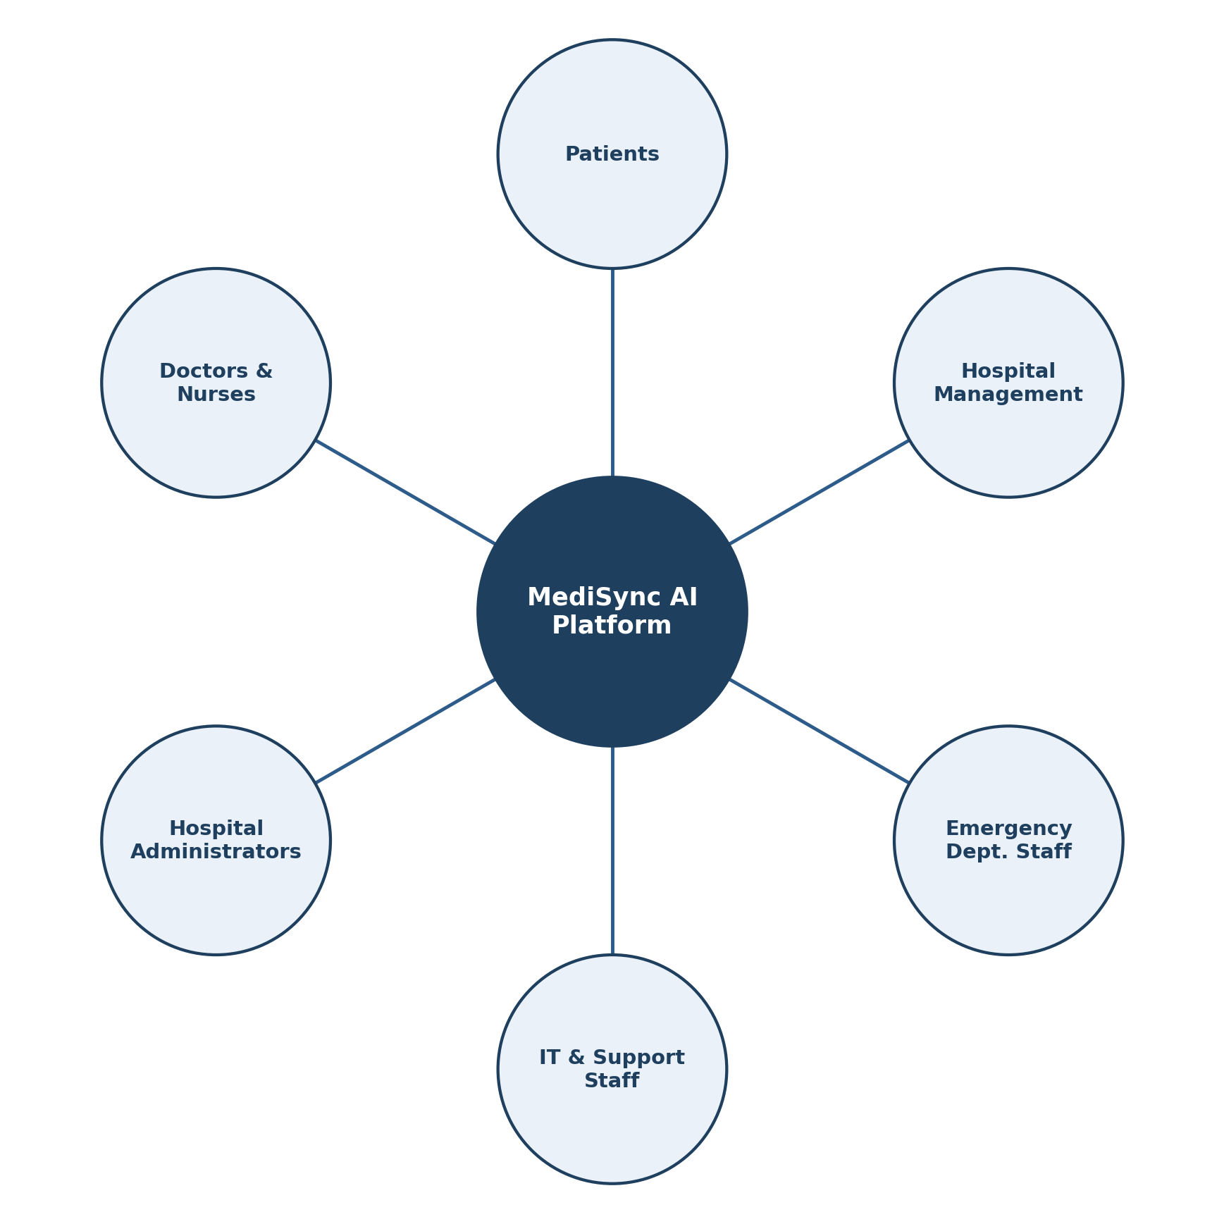

Figure 1: Stakeholder Map for MediSync AI
Stakeholder | Role & Responsibility | Key Challenge
Patients | Receive treatment and care | Long waiting times, unclear treatment timelines, poor communication about delays
Doctors & Nurses | Diagnose, treat, and monitor patients | Difficulty finding free beds/equipment, unbalanced workload, delayed information about incoming patients
Hospital Administrators | Manage overall hospital operations and resources | No real-time visibility of bed/staff/equipment status; reactive rather than proactive planning
IT & Support Staff | Maintain hospital software systems and infrastructure | Disconnected legacy systems that do not share data easily
Emergency Department Staff | Handle urgent, high-priority patient cases | Sudden patient surges with no early warning, leading to overcrowding
Hospital Management / Board | Set policy, budget, and long-term strategy | Lack of predictive data to plan capacity, staffing, and budget in advance

3. Analysis of the Current Approach
How Hospitals Currently Work
Most hospitals today rely on a mix of manual coordination, spreadsheets, and separate departmental software to track beds, staff schedules, and equipment. Admissions, transfers, and discharges are often communicated by phone calls or paper forms, and different departments — such as the emergency room, wards, and labs — usually keep their own records without sharing them easily with one another.
Strengths of the Current System
- Familiarity: Staff are used to existing manual and paper-based routines.
- Low upfront cost: No major software investment is needed to keep running as-is.
- Human judgment: Experienced staff can adapt to unusual situations using personal expertise.
Limitations and Gaps
- No real-time visibility: Bed and equipment status is often outdated or inaccurate.
- No prediction: Hospitals react to overcrowding instead of preparing for it in advance.
- Departmental silos: Systems don't share data, which slows down patient transfers.
- Manual errors: Phone- and paper-based coordination is slow and prone to mistakes.
These gaps show that a smarter, connected, and predictive system is needed — which is exactly what the proposed MediSync AI platform aims to provide.

4. Proposed Software Solution
MediSync AI is designed as a layered software platform. It pulls data from hospital IT systems and IoT sensors into one central pipeline, runs that data through AI models to predict demand, and uses an optimization engine to recommend the best allocation of beds, staff, and equipment. The results are shown to hospital staff through a real-time dashboard.
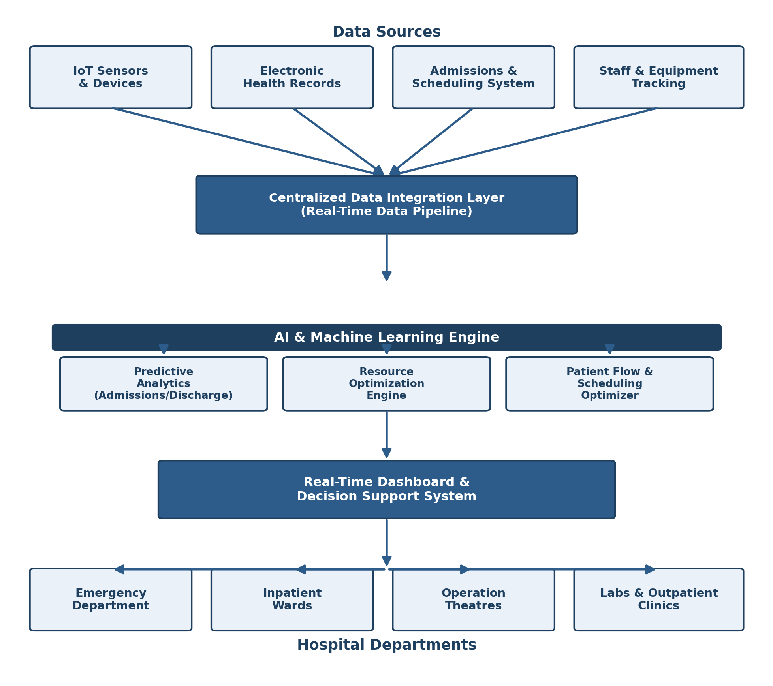
Figure 2: High-Level System Architecture of MediSync AI
Major Functional Modules
- Data Integration Module: Collects data from IoT sensors, health records, and admission systems into one pipeline.
- Predictive Analytics Module: Forecasts patient admissions, discharge times, and resource demand.
- Resource Optimization Module: Recommends the best allocation of beds, staff, and equipment.
- Patient Flow & Scheduling Module: Coordinates movement of patients between departments.
- Dashboard Module: Displays real-time insights and alerts to hospital staff.
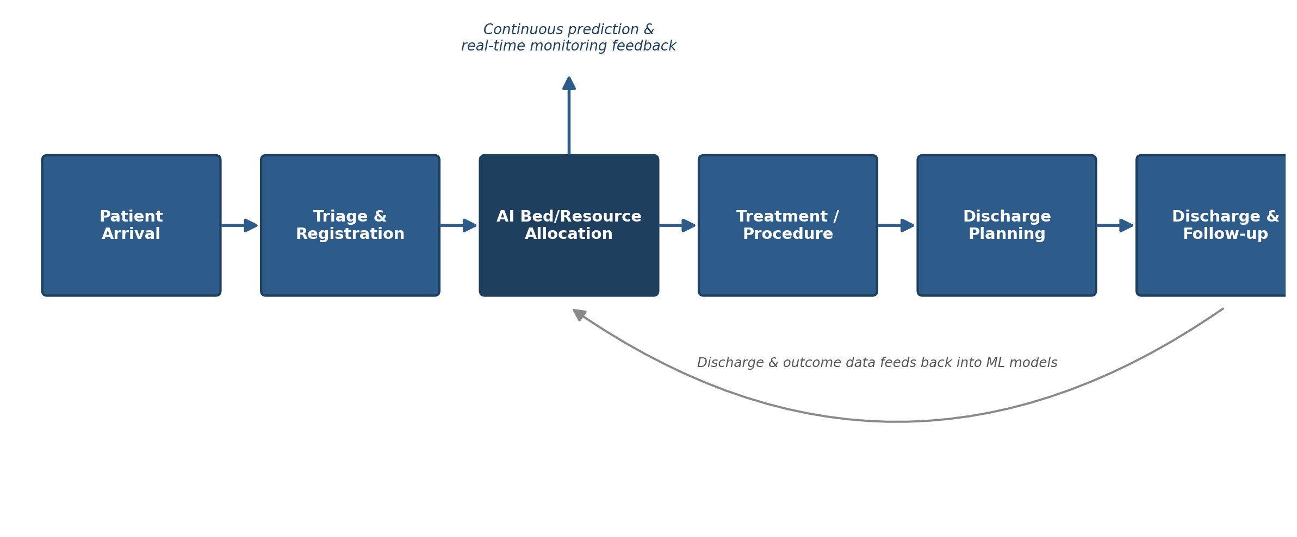
Figure 3: Patient Flow Through the Proposed System
Functional Requirements
- The system shall collect real-time data on bed, staff, and equipment availability.
- The system shall predict patient admissions and discharge times using machine learning models.
- The system shall recommend optimal allocation of beds, staff, and equipment across departments.
- The system shall display real-time dashboards to hospital administrators and medical staff.
- The system shall generate alerts for predicted overcrowding or resource shortages.
- The system shall support patient scheduling and interdepartmental transfer coordination.
Non-Functional Requirements
- Performance: The system should process and update data in near real time (within a few seconds).
- Scalability: The system should support additional hospital departments or facilities without redesign.
- Reliability: The system should remain available and accurate, since hospital operations depend on it.
- Usability: The dashboard should be simple enough for non-technical hospital staff to use.
- Security: Patient data must be protected in line with healthcare data privacy standards.
- Maintainability: The system should be easy to update as hospital processes or regulations change.
How Software Engineering Principles Are Applied
- Modularity: The system is split into independent modules (data, prediction, optimization, dashboard) that can be built and updated separately.
- Scalability: New departments, hospitals, or sensors can be added without redesigning the whole system.
- Maintainability: Clear module boundaries make it easier to fix bugs or update one part without affecting others.
- Reliability: The system is designed to stay accurate and available, since hospitals depend on it continuously.
- Usability: The dashboard is kept simple and visual so non-technical hospital staff can use it easily.
- Security: Patient data is protected using access controls and encryption to meet healthcare privacy standards.

5. Methodology / Framework Justification
The Agile software development methodology is recommended for building MediSync AI. Agile breaks the project into short cycles called sprints, where a working piece of the system is built, tested, and reviewed before moving to the next feature. This fits well with a hospital AI system, where requirements (like which predictions matter most to staff) often become clearer only after early versions are tested with real users.
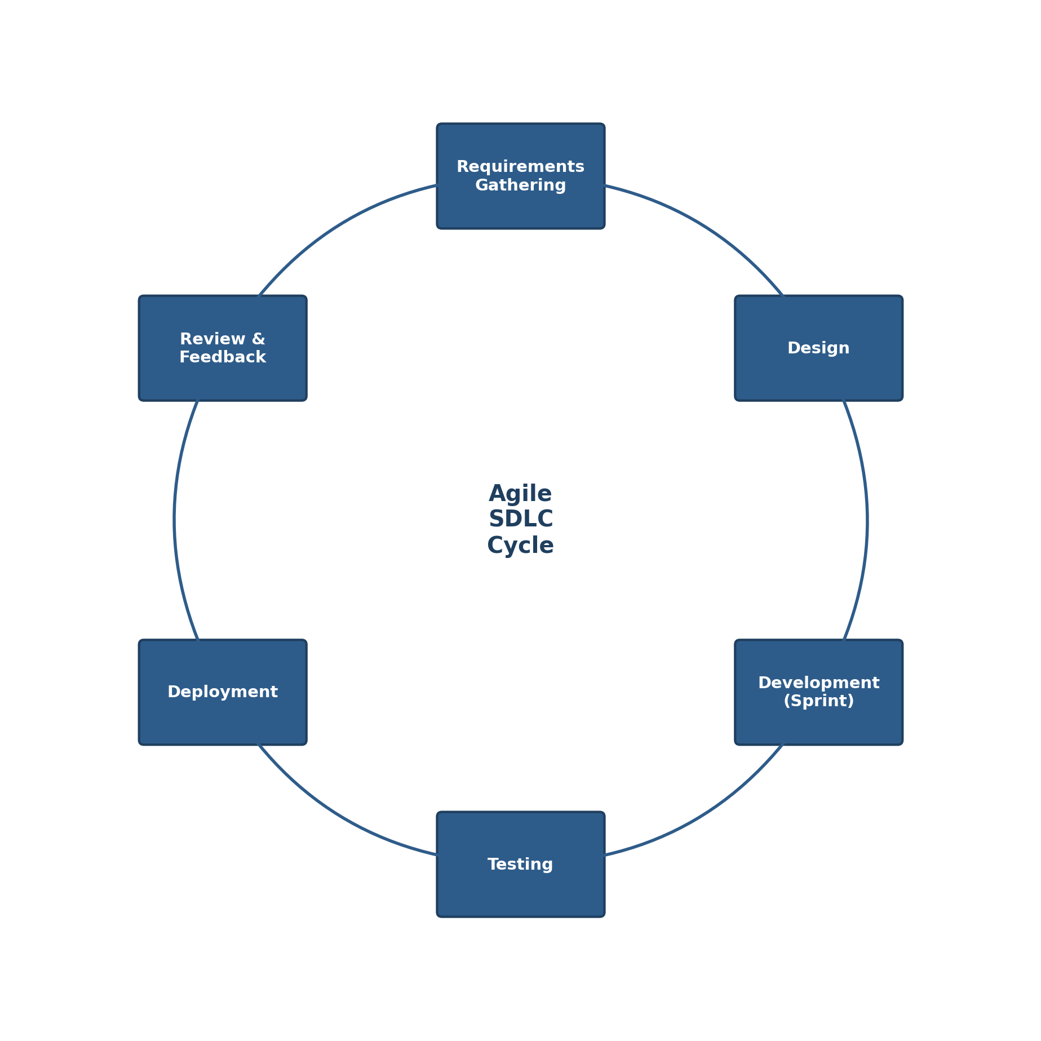
Figure 4: Agile SDLC Cycle Applied to MediSync AI
Why Agile Fits This Project
- Changing requirements: Hospital staff feedback can be included quickly after each sprint, instead of waiting until the end of the project.
- Early and continuous testing: Since patient safety is involved, frequent testing throughout development helps catch problems early.
- Incremental delivery: Core features like bed tracking can be delivered first, with prediction and optimization added in later sprints.
- Better collaboration: Regular sprint reviews keep doctors, administrators, and developers aligned on priorities.
This approach supports long-term maintenance as well, since new features (such as ambulance optimization) can be added as separate future sprints without disrupting the live system.

6. Expected Outcomes and Limitations
Expected Outcomes
- Reduced patient waiting times and treatment delays.
- Improved utilization of hospital beds, staff, and medical equipment.
- Enhanced patient flow across hospital departments.
- Increased operational efficiency through AI-driven resource optimization.
- Better decision-making using predictive analytics and real-time dashboards.
- Higher patient satisfaction and improved quality of healthcare services.
- Reduced hospital operational costs through optimized resource management.
- A scalable intelligent hospital management system supporting smart healthcare initiatives.
How These Outcomes Address the Identified Challenges
By giving real-time visibility into beds, staff, and equipment, the system directly solves the problem of outdated information described in Section 3. By predicting patient demand in advance, it shifts hospitals from reacting to overcrowding to preparing for it, addressing the challenges faced by both administrators and emergency department staff identified in Section 2.
Limitations and Risks
- Prediction accuracy depends on the quality and volume of historical data available; new hospitals with little data may see weaker forecasts at first.
- Staff will need training to trust and correctly use AI-based recommendations instead of habitual manual processes.
- Integrating with older, legacy hospital IT systems may require extra effort and custom connectors.
- Sensitive patient data handled by the system must be carefully secured to meet privacy regulations.
Possible Future Enhancements
- Add deep learning models for more accurate long-term demand forecasting.
- Integrate wearable patient-monitoring devices for continuous vital sign tracking.
- Extend the platform to optimize ambulance dispatch and inter-hospital transfers.
- Build a patient-facing mobile app showing expected wait times and appointment updates.

7. Implementation Roadmap and Timeline
A phased rollout is recommended so that MediSync AI can be introduced into live hospital operations without disrupting existing patient care. Each phase builds on the previous one, starting with the most critical real-time visibility features and progressing toward full predictive and optimization capabilities.
- Phase 1 – Pilot Deployment (Months 1–2): Deploy the Data Integration Module and real-time dashboard in a single department, such as the emergency ward, to validate data feeds and staff adoption.
- Phase 2 – Core Module Rollout (Months 3–5): Extend the Dashboard and Patient Flow & Scheduling Modules hospital-wide, connecting all departments to the central data pipeline.
- Phase 3 – Predictive Analytics Integration (Months 6–8): Introduce the Predictive Analytics Module, train forecasting models on collected historical data, and begin generating admission and discharge predictions.
- Phase 4 – Full-Scale Optimization (Months 9–12): Activate the Resource Optimization Module and automated alerts, then review performance metrics and expand the system to additional facilities.

8. Cost-Benefit Analysis
Adopting MediSync AI requires upfront investment in software development, integration, and staff training, but is expected to generate savings and efficiency gains that outweigh these costs over time.
- Development and Licensing: One-time cost of building or licensing the platform, including the data pipeline, AI models, and dashboard interface.
- Integration and Infrastructure: Cost of connecting existing hospital IT systems and IoT sensors, and provisioning servers or cloud infrastructure.
- Training and Change Management: Ongoing cost of preparing hospital staff to trust and correctly use AI-generated recommendations.
- Projected Benefits: Reduced waiting times, better staff utilization, fewer emergency overcrowding incidents, and lower operational costs from more efficient resource use are expected to offset the initial investment within one to two years of full deployment.

9. Risk Management Plan
As with any AI system deployed in a healthcare setting, MediSync AI carries risks that must be actively managed throughout development and operation.
- Data Privacy and Security Risk: Mitigated through role-based access controls, encryption of patient data in transit and at rest, and compliance with healthcare data privacy standards.
- Model Accuracy Risk: Mitigated by continuously retraining prediction models with new hospital data and clearly flagging low-confidence forecasts to staff.
- Staff Adoption Risk: Mitigated through hands-on training, a simple and intuitive dashboard design, and phased rollout that builds trust gradually.
- System Downtime Risk: Mitigated by redundant infrastructure and fallback manual procedures so hospital operations can continue if the system is temporarily unavailable.

Conclusion
This case study analyzed the problem of inefficient hospital resource and patient flow management, and proposed MediSync AI as a software-based solution grounded in sound software engineering principles. By combining real-time data integration, predictive analytics, and resource optimization, the proposed system addresses the key challenges faced by patients, medical staff, and hospital administrators. Using the Agile methodology for development ensures the system can evolve based on real user feedback, making it a practical and scalable solution for modern, data-driven healthcare delivery.

